Thank You!
Good Samaritans and helpful neighbors are key components for a thriving community. We greatly appreciate your willingness to help someone during their time of need until our personnel arrived on scene. Unfortunately, some of these incidents can be tragic and have unfavorable outcomes. Bystanders may struggle to cope with their experience of these potentially traumatic events.

If you’re experiencing any signs or symptoms relative to post-traumatic-stress disorder (PTSD), or simply need to speak to someone to help put things into perspective, don’t hesitate to contact someone! These emotions are normal and there are numerous resources available. The website and QR code on the back of this card will link you to some of those valuable resources.

Agency Name

Agency Slogan

https://www.cdc.gov/masstrauma/factsheets/public/coping.pdf

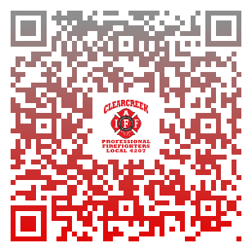
Agency website
Agency Name

Address Goes Here

Phone Number

